**CAASFEP Scholarship Program 2025** 

**PURPOSE**

The purpose of the scholarship program is to financially support post-secondary education for nine qualifying high school seniors attending their first year of college with a $3,000 contribution to their tuition costs.

**ELIGIBILITY**

High school students who are on track to graduate by the conclusion of the 2024-25 academic year and demonstrate a financial need are eligible to apply for the CAASFEP scholarship. Financial need will be determined by eligibility for the free or reduced lunch program at the school (as indicated in the SIS, not to be confused with benefiting from the Universal Meals program) or qualifying as Socio-economically Disadvantaged (SED). The principal or counselor will certify eligibility for one of these programs on the application. In addition, the applicant must be enrolled in a public school and **must be sponsored be a CAASFEP member**.

**SELECTION PROCESS**

Scholarship winners will be selected based upon the following criteria:

| **Criteria** | **Points** |
| --- | --- |
| 1. Completed scholarship application form, documents, and checklist | N/A |
| 1. GPA, based on the applicant’s most recent High School transcript at the time of submitting the application | 20 points |
| 1. Three letters of recommendation: One from the student’s high school principal or administrative designee on school letterhead, one from a faculty member/advisor on school’s letterhead, and one from a non-family member. | 15 points |
| 1. School, community service, leadership and work activities or experiences in which the applicant participated during grades 9th - 12th grade, including leadership positions held. | 15 points |
| 1. A personal essay of 350 - 500 words that reflects proper conventions of writing and fully addresses the required discussion points (See Application Checklist for discussion points.) | 50 points |

**SCHOLARSHIP PAYMENT**

The full amount of each scholarship will be made payable to the institution of the recipient’s choice for the 2024-25 academic year. It is the responsibility of each scholarship recipient to forward enrollment verification and a tuition invoice from the institution to the CAASFEP scholarship chairperson. Please note that the scholarship is paid directly to the institution.

**APPLICATION PROCESS**

**Application window: January 20, 2025 through April 5, 2025**

Email the completed application, with all components scanned as one attachment, to the person named below that is the scholarship chair for your county:

| County Name | Name of Scholarship Chair | Email Address |
| --- | --- | --- |
| Los Angeles; Orange | Lisa Winberg | [lwinberg@rcoe.us](mailto:lwinberg@rcoe.us) |
| San Diego; Riverside; Imperial | James Koenig | [jkoenig@vcoe.org](mailto:jkoenig@vcoe.org) |
| All Other Counties | Rebecca Aguila | [raguila@fcoe.org](mailto:raguila@fcoe.org) |

**CAASFEP SCHOLARSHIP APPLICATION 2025**

**Application Checklist and Cover Sheet**

Use this Checklist as a cover sheet for each Packet.

A **completed Scholarship Application Packet** includes ALL of the following documents and ALL required signatures.

|  | **Completed Scholarship Application Form,** including all four parts; | | |
| --- | --- | --- | --- |
|  | |  | **Application Checklist,** with applicant’s signature and date |
|  | |  | **Part 1**: CAASFEP Representative Information |
|  | |  | **Part 2**: Applicant’s Information |
|  | |  | **Part 3**: List of School, Community Service, Leadership, and Work Activities/Experiences |
|  | |  | **Part 4**: Certification of Applicant’s High School Completion Status and Certification of Financial Need by high school principal, designee, or counselor |
|  | |  | (Applicant – Please include the date the principal is to return this form to you in the form.) |
|  | |  |
|  | **Personal Essay** (typed, 350 - 500 words) in which the applicant covers all five areas described below: | | |
|  | 1. Explains the reasons for applying for the scholarship, including circumstances that demonstrate a financial need and how the circumstances impact attending college; 2. Describes a personal experience with adversity & the impact on self; 3. Describes an experience when the applicant demonstrated leadership skills or qualities and the impact on self or others; 4. Describes an experience when the applicant demonstrated personal responsibility and the impact on self or others; AND 5. Discusses future goals and why they are important. | | |
|  |  | | |
|  | **Fall 2024 High School transcript** | | |
|  |  | | |
|  | **Three letters of recommendation:** | | |
|  | 1. One from the applicant’s high school principal or administrative designee **(on school/district letterhead)** 2. One from a faculty member or advisor **(on school/district letterhead)** 3. One from a non-family member | | |
|  | **Use this Application Checklist with the Applicant’s Signature as a Cover Sheet** | | |

|  | Initials - My initials verify my understanding that to be eligible for the CAASFEP Scholarship, I must be enrolled in a public charter school or school district with at least one current CAASFEP member. |
| --- | --- |

| **Applicant’s Signature:** |  | Date: |  |
| --- | --- | --- | --- |

| **CAASFEP Member’s Signature:** By signing below, I verify that our LEA nominates this applicant for the 2025 CAASFEP scholarship and confirm that the applicant meets all eligibility requirements.  CAASFEP Rep’s Signature: ____________________________________________________ Date: ________________ | |
| --- | --- |
| CAASFEP Rep’s Full Name (Please Print): |  |

**CAASFEP SCHOLARSHIP APPLICATION 2025**

**Part 1: CAASFEP Member Information**

| Name of CAASFEP Representative: |  |
| --- | --- |
| LEA (Name of school district or charter school): |  |

**Part 2: Applicant’s Information** (To be completed by the applicant.)

| Applicant’s Full Name: | | | |  | | | | | |
| --- | --- | --- | --- | --- | --- | --- | --- | --- | --- |
| Mailing Address: | | |  | | | | | | |
| City, State, and ZIP Code: | | | | |  | | | | | |
| Email: |  | | | | | | Phone: | |  |
| High School: | |  | | | | Local School District: | |  | |

| I plan to pursue a degree in: |  |
| --- | --- |

| **Institutional Preferences** | | **Estimated Tuition and**  **Educational Expenses** | **Date Accepted**  (if applicable) |
| --- | --- | --- | --- |
| 1st Choice |  |  |  |
| 2nd Choice |  |  |  |
| 3rd Choice |  |  |  |

| **Part 3: School, Community Service, Leadership, and Work Activities/Experiences**  Please***list*** activities in which you have actively participated during high school (grades 9-12), either at school or outside of school. Include any leadership positions or roles you might have held with school or community groups or organizations. For each activity, put the number of years you participated in parentheses. [Ex. *Debate Team (2 yrs)]*. (Include as an attachment, if preferred.) |
| --- |
|  |

**CAASFEP SCHOLARSHIP APPLICATION 2025**

**Part 4: Certification of Applicant’s High School Completion Status and Demonstration of Financial Need**

| Applicant’s Name: |  | Student ID Number: |  |
| --- | --- | --- | --- |

The applicant should sign below and request the High School Principal, the principal’s designee, or counselor complete the Demonstration of Financial Need by the date indicated by the applicant.

I, _________________________________hereby authorize ______________________________________________

*(Name of applicant) (Name of Principal, designee, and/or counselor)*

to advise the CAASFEP Board as to my demonstrated financial need for the purposes of my application for the CAASFEP *Scholarship Program.*

Signed: Date: ______________________  *(Applicant)*

**To be completed by the High School Principal, Admin Designee, or Counselor:**

I certify that the student named above qualifies (mark with an X all that apply):

______for free or reduced price meals as indicated in our student information system (sample screenshot on next page). Do not check this box if the student receives free meals through the universal meals program, but does not have this designation in the SIS.

______as an English Learner (EL) or Reclassified Fluent English Proficient (RFEP)

______as Socioeconomically Disadvantaged (SED)

______for none of the above named programs.

High School School Phone_________________________

|  | By checking this box, I certify that this student is a high school senior and is currently on track |
| --- | --- |
|  | to meet the established criteria for obtaining a high school diploma by the conclusion of the 2024-25 academic year. |

| **Principal, Designee, or Counselor Signature:** |  | **Date:** |  |
| --- | --- | --- | --- |
| **Name (Print):** |  |  |  |
| **Role (Principal, Admin Designee, or Counselor)** |  |  |  |

| **Please return this completed form to the applicant by:** |  |
| --- | --- |

(The Applicant must include a return date)

All users may not have access to free/reduced price status within the Student Information System (SIS). If you do not have the proper authorization to view this info, you may have to check with your district CALPADS coordinator to verify student’s free/reduced lunch or SED status. Samples below come from two of the most common SISs in the state. If you use a different system, you may have to check with your SIS coordinator to see where this information is found within your system.

SAMPLE free.reduced program screen from Aeries:

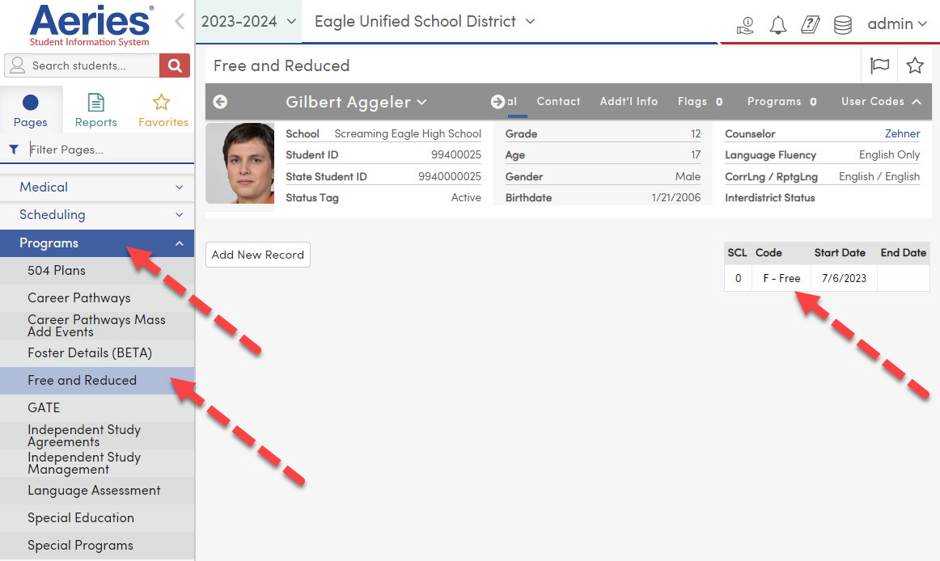

SAMPLE free.reduced program screen from Infinite Campus:

